

**VISVESVARAYA**

**TECHNOLOGICAL**

**UNIVERSITY**

**“JnanaSangama”,**

**Belgaum**

**-590014**

**,**

**Karnataka.**

**LAB**

**REPORT**

**on**

**COMPUTER**

**NETWORKS**

***Submitted***

***by***

**Himani bohara**

**(1BM22CS112)**

***in***

***partial***

***fulfillment***

***for***

***the***

***award***

***of***

***the***

***degree***

***of***

**BACHELOR**

**OF**

**ENGINEERING**

***in***

**COMPUTER**

**SCIENCE**

**AND**

**ENGINEERING**

**B.M.S.**

**COLLEGE**

**OF**

**ENGINEERING**

**(**

**Autonomous**

**Institution**

**under**

**VTU)**

**BENGALURU-560019**

**Sep**

**2024-**

**Jan**

**2025**



**B.**

**M.**

**S.**

**College**

**of**

**Engineering,**

**Bull**

**Temple**

**Road,**

**Bangalore**

**560019**

(

Affiliated

To

Visvesvaraya

Technological

University,

Belgaum)

**Department**

**of**

**Computer**

**Science**

**and**

**Engineering**

**CERTIFICATE**

This

is

to

certify

that

the

Lab

work

entitled

“

**COMPUTER**

**NETWORKS**

”

carried

out

by

**Himani Bohara**

**(1BM22CS112)**

who

is

bonafide

student

of

**B.**

**M.**

**S.**

**College**

**of**

**Engineering.**

It

is

in

partial

fulfillment

for

the

award

of

**Bachelor**

**of**

**Engineering**

**in**

**Computer**

**Science**

**and**

**Engineering**

of

the

Visvesvaraya

Technological

University,

Belgaum

during

the

year

2024-25.

The

Lab

report

has

been

approved

as

it

satisfies

the

academic

requirements

in

respect

of

**Computer**

**Networks**

**Lab**

**-**

**(23**

**)**

**CS5PCCON**

work

prescribed

for

the

said

degree.

**Dr.**

**Nandhini**

**Vineeth**

**Dr.**

**Kavitha**

**Sooda**

Associate

Professor,

Professor

and

Head,

Department

of

CSE,

Department

of

CSE

BMSCE,

Bengaluru

BMSCE,

Bengaluru



**INDEX**

CYCLE 1

|  |  |  |  |
| --- | --- | --- | --- |
| **Sl. No.** | **Date** | **Experiment Title** | **Page No.** |
| 1 | 25-09-2024 | Create a topology and simulate sending a simple PDU from source to destination using hub and switch as connecting devices and demonstrate ping message. | 5-7 |
| 2 | 09-10-2024 | Configure IP address to routers in packet tracer. Explore the following messages: ping responses, destination unreachable, request timed out, reply | 8-9 |
| 3 | 16-09-2024 | Configure default route, static route to the Router | 10-13 |
| 4 | 13-11-2024 | Configure DHCP within a LAN and outside LAN. | 14-16 |
| 5 | 20-11-2024 | Configure RIP routing Protocol in Routers | 17-18 |
| 6 | 20-11-2024 | Demonstrate the TTL/ Life of a Packet | 19-20 |
| 7 | 27-11-2024 | Configure OSPF routing protocol | 21-23 |
| 8 | 18-12-2024 | Configure Web Server, DNS within a LAN | 24-25 |
| 9 | 18-12-2024 | To construct simple LAN and understand the concept and operation of Address Resolution  Protocol (ARP) | 26-27 |
| 10 | 18-12-2024 | To understand the operation of TELNET by accessing the router in server room from a PC in IT office | 28-29 |
| 11 | 18-12-2024 | To construct a VLAN and make the PC’s communicate among a VLAN | 30-32 |
| 12 | 18-12-2024 | To construct a WLAN and make the nodes communicate wirelessly | 33-35 |

**INDEX**

CYCLE 2

|  |  |  |  |
| --- | --- | --- | --- |
| **Sl. No.** | **Date** | **Experiment Title** | **Page No.** |
| 1 | 01-01-2025 | Write a program for error detecting code using CRC-CCITT (16-bits). | 36-39 |
| 2 | 01-01-2025 | Write a program for congestion control using Leaky bucket algorithm. | 40-42 |
| 3 | 01-01-2025 | Using TCP/IP sockets, write a client-server program to make client sending the file name and the server to send back the contents of the requested file if present | 43-45 |
| 4 | 01-01-2025 | Using UDP sockets, write a client-server program to make client sending the file name and the server to send back the contents of the requested file if present. | 46-48 |
| 5 | 03-01-2025 | Tool Exploration -Wireshark | 49 |

# CYCLE-1

Question 1:

Create a topology and simulate sending a simple PDU from source to destination using hub and switch as connecting devices and demonstrate ping message.

Observation:

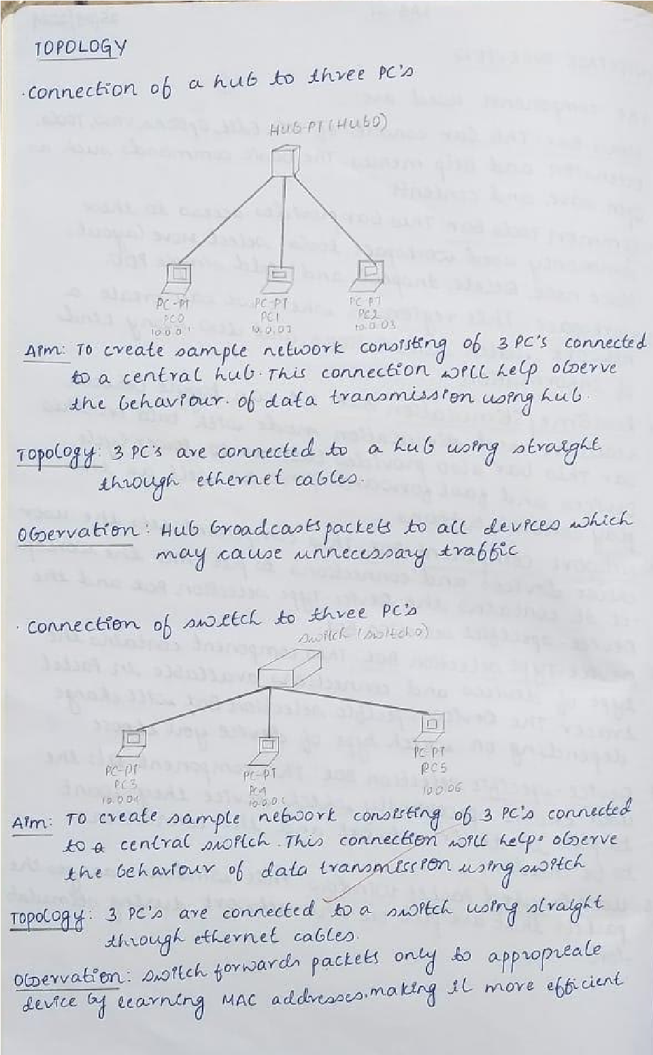

Screenshot of the topology:

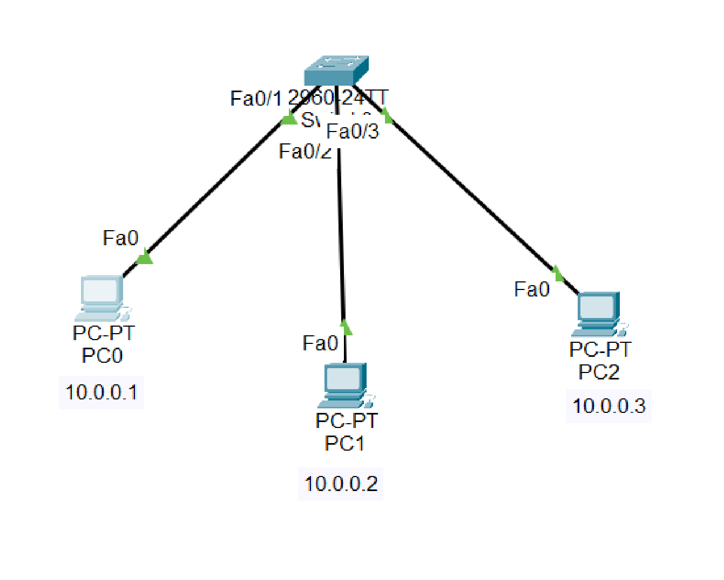

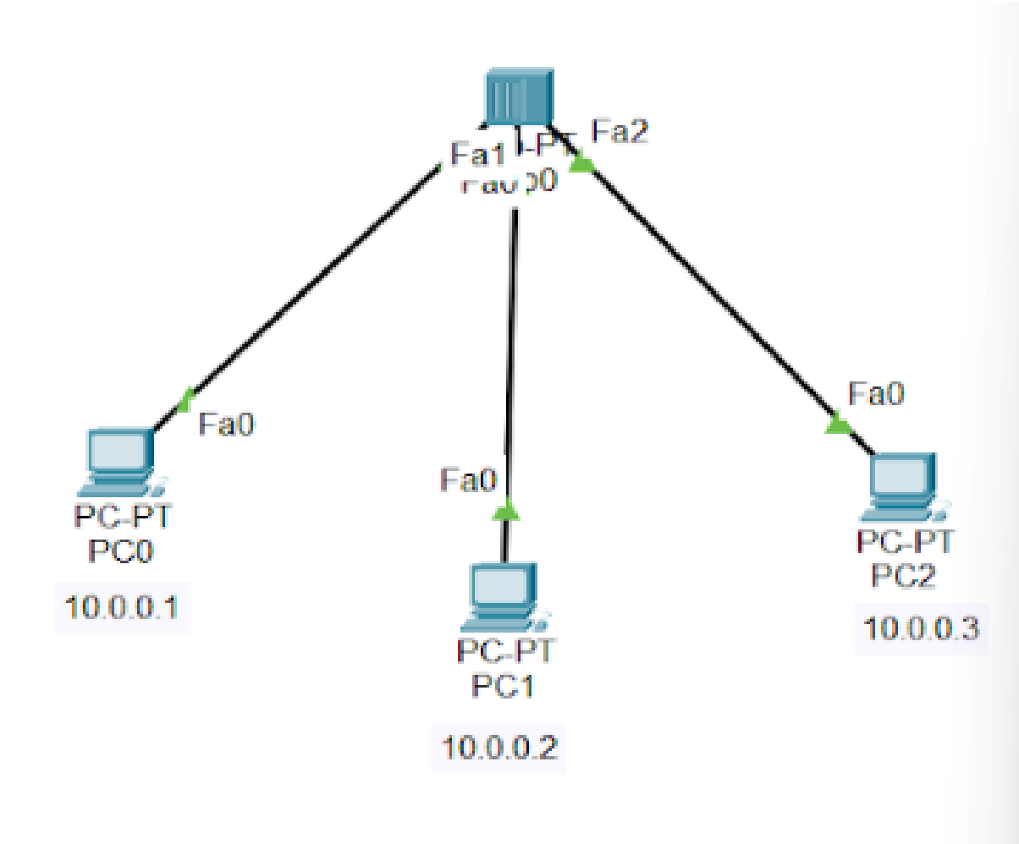

Screenshot of the output:

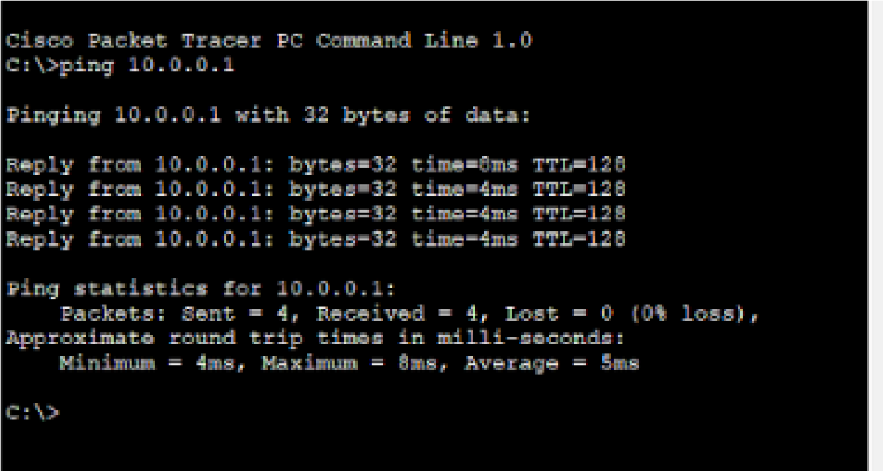

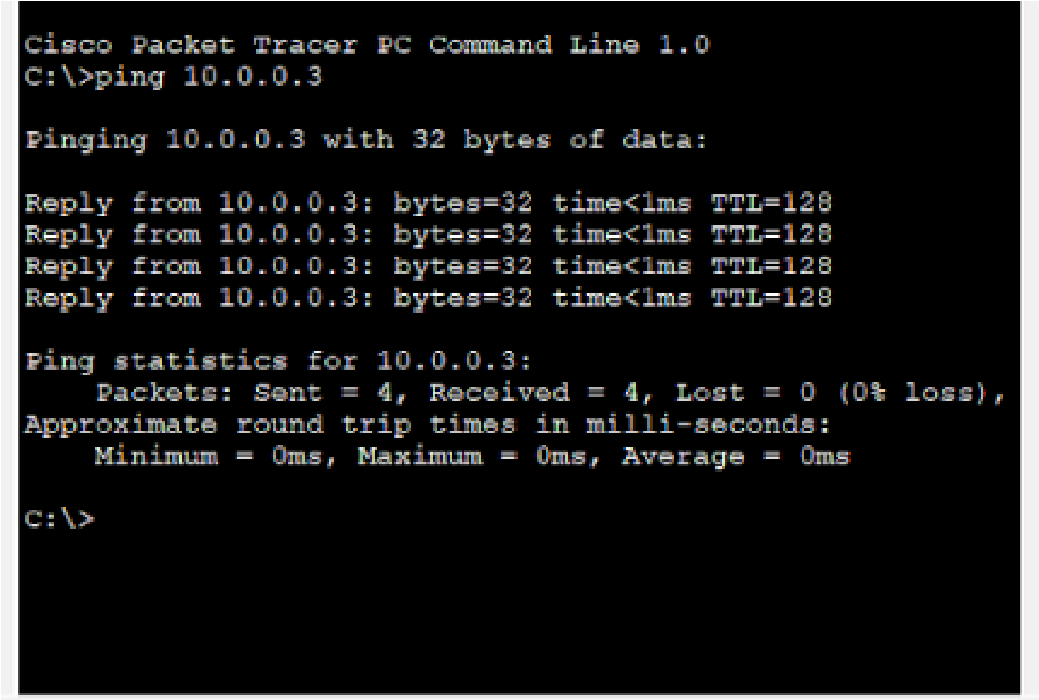

Question 2:

Configure IP address to routers in packet tracer. Explore the following messages: ping responses, destination unreachable, request timed out, reply

Observation:

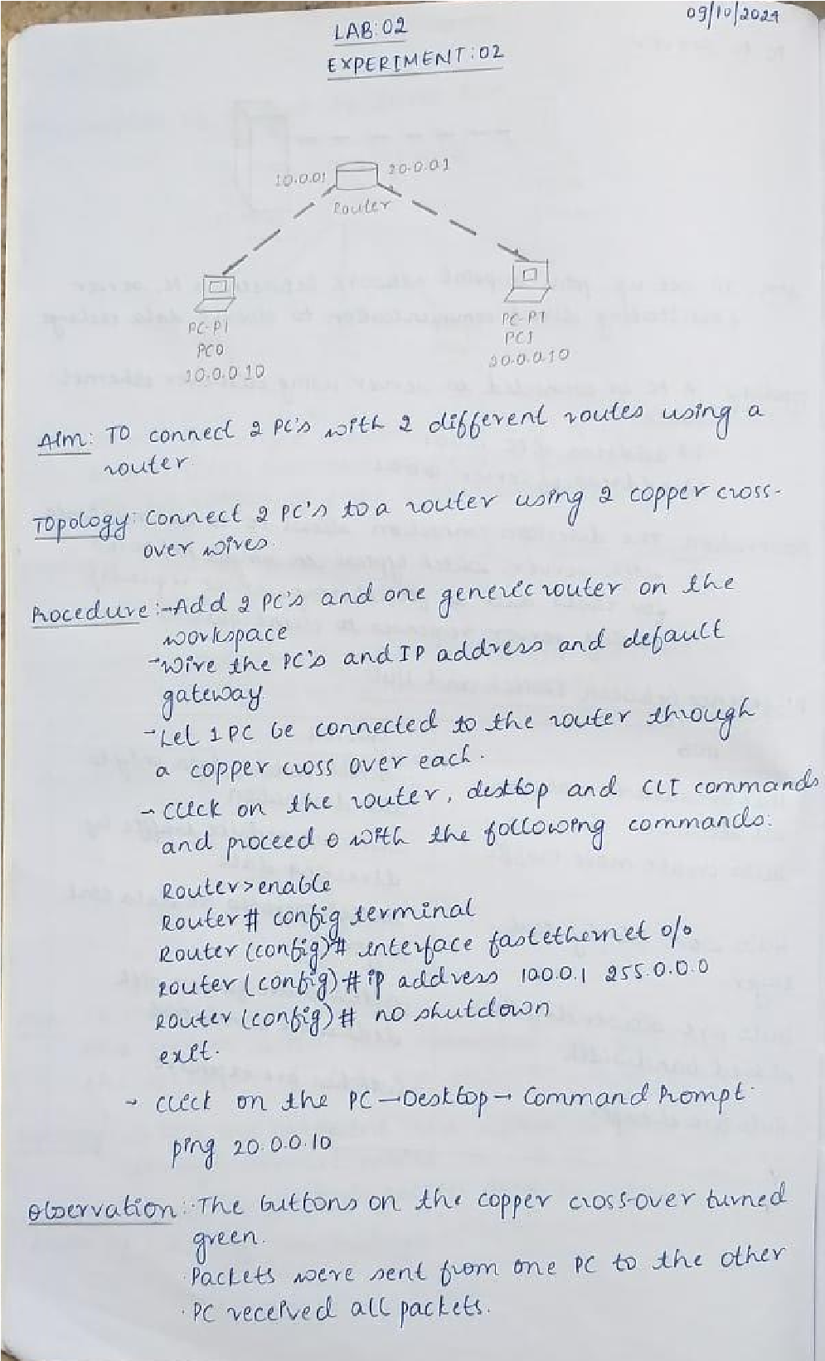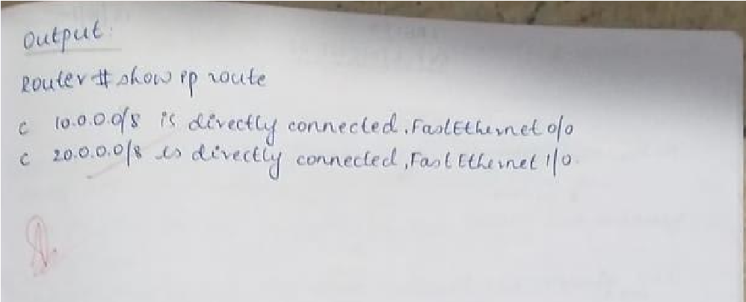

Screenshot of the topology:

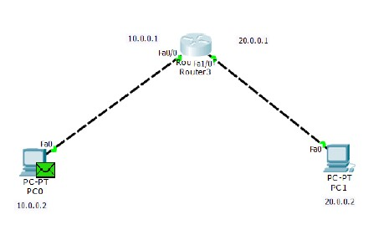

Screenshot of the output:

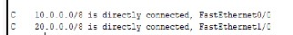

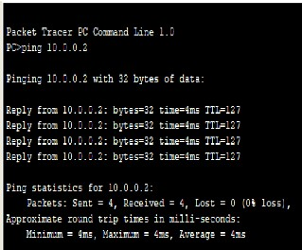

Question 3:

Configure default route, static route to the Router

Observation:

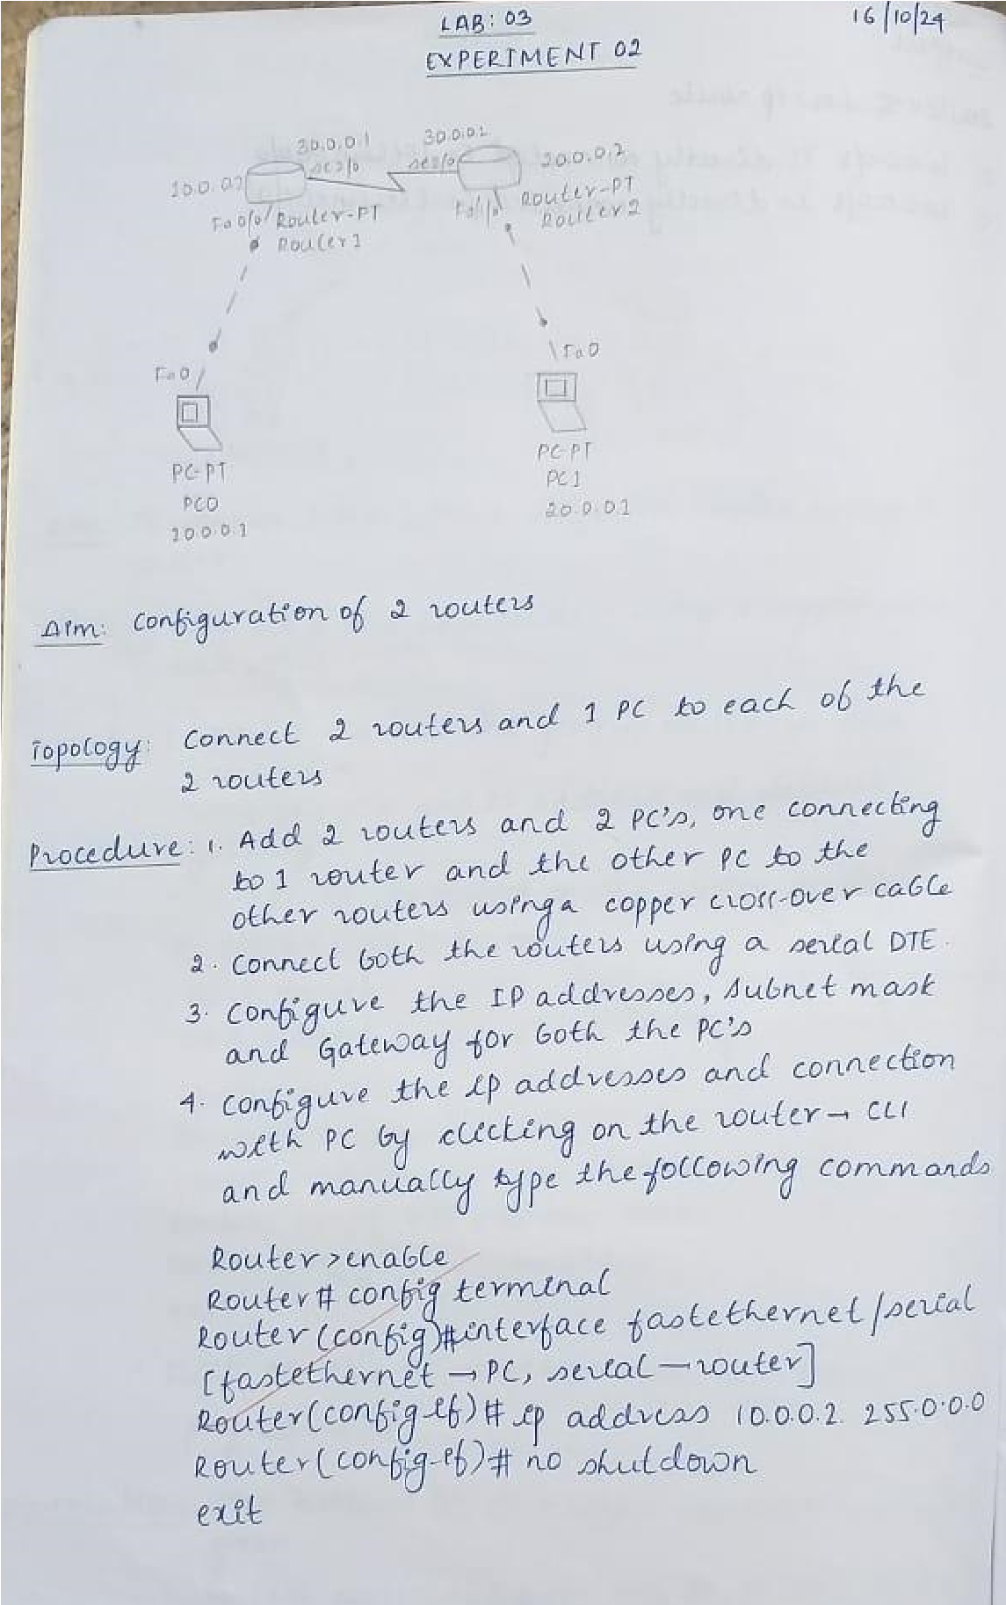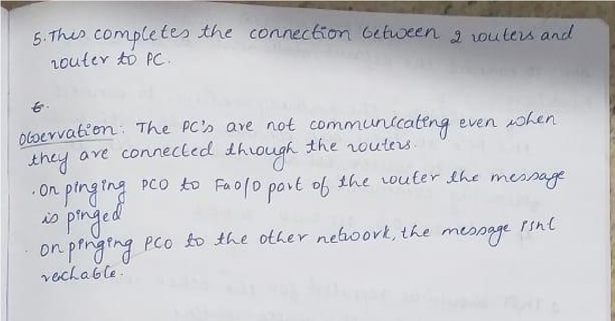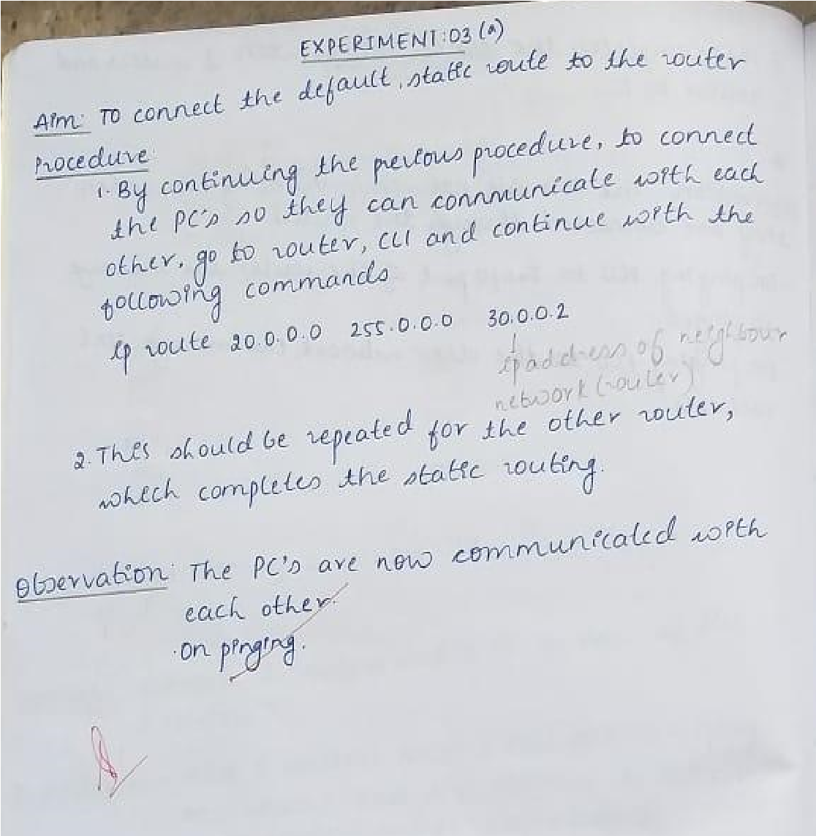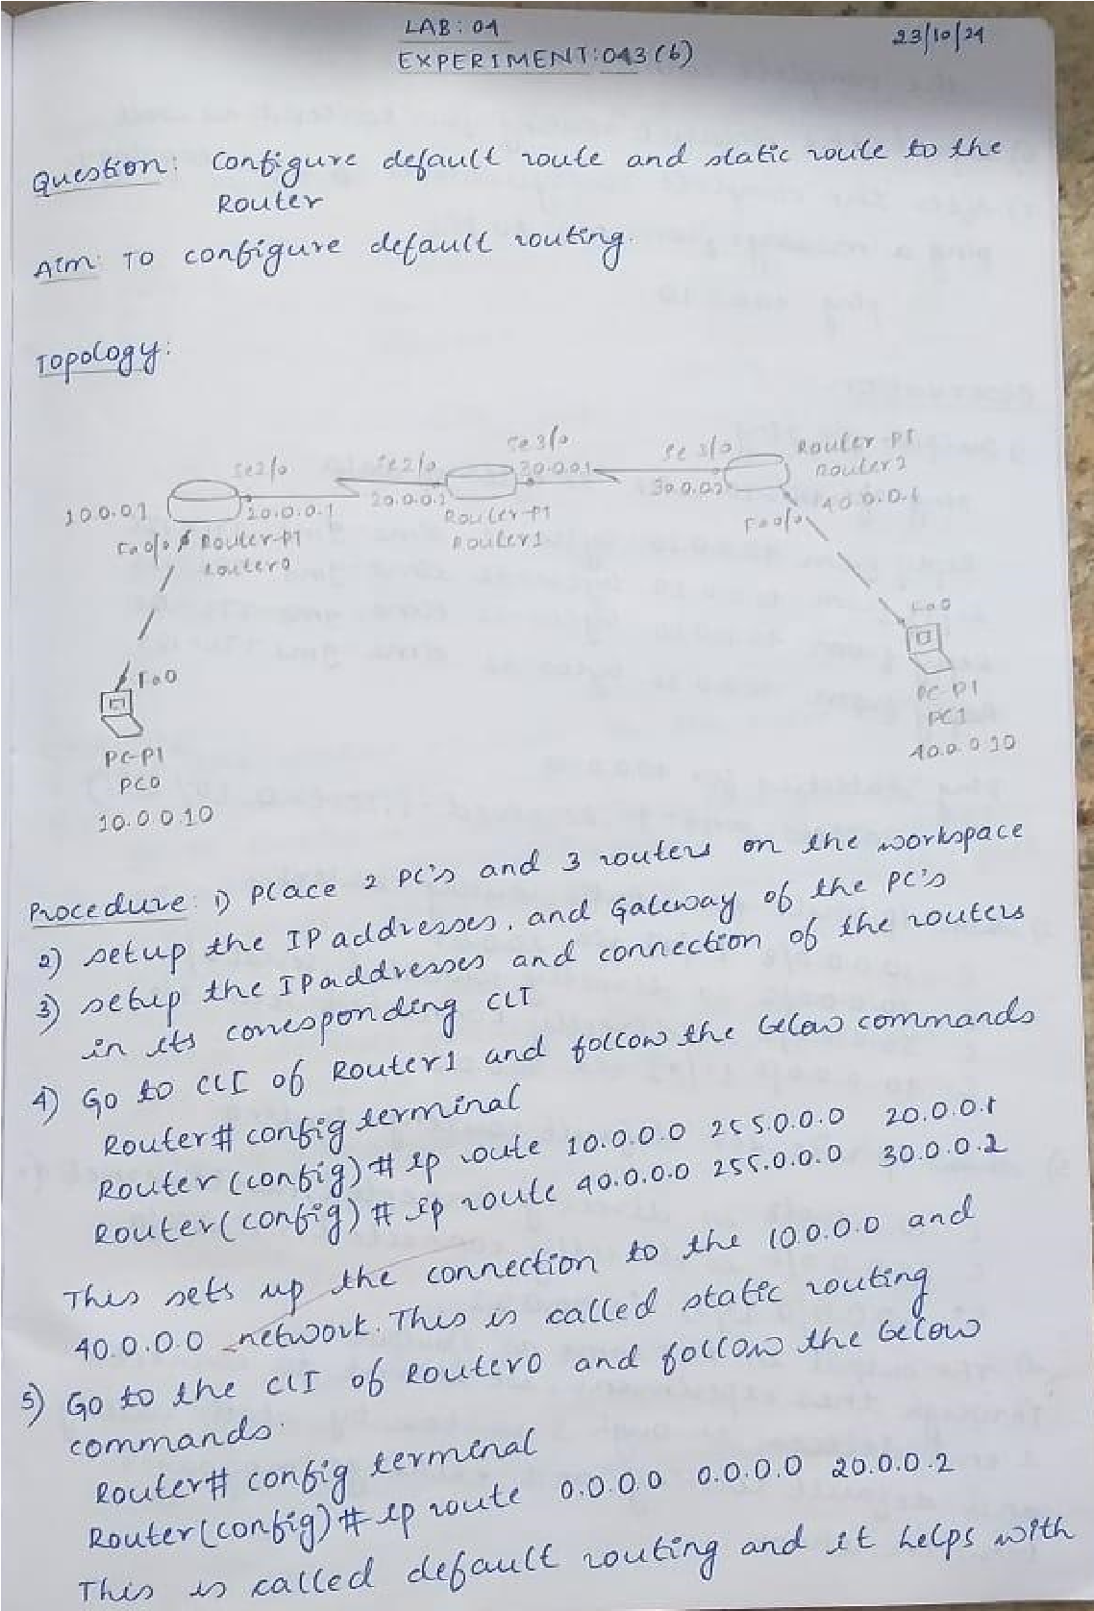

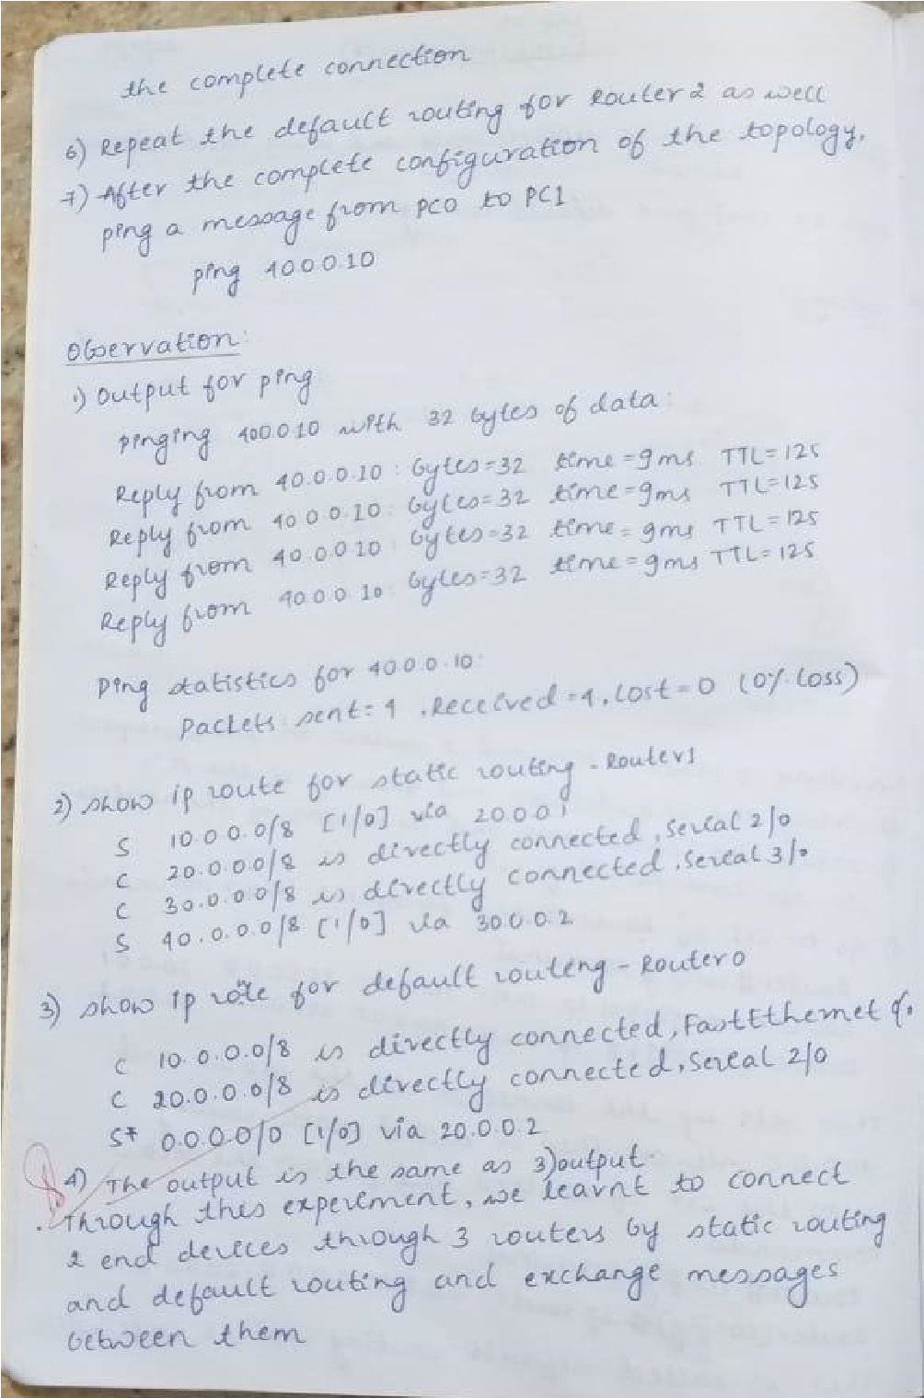

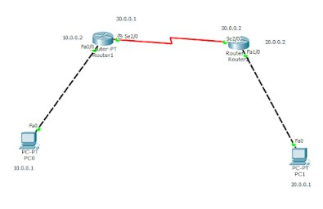Screenshot of the topology:

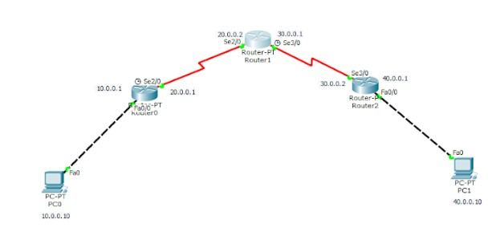

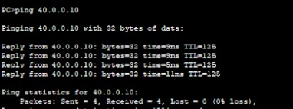Screenshot of the output:

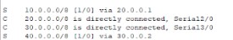

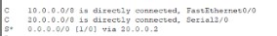

Question 4:

Configure DHCP within a LAN and outside LAN.

Observation:

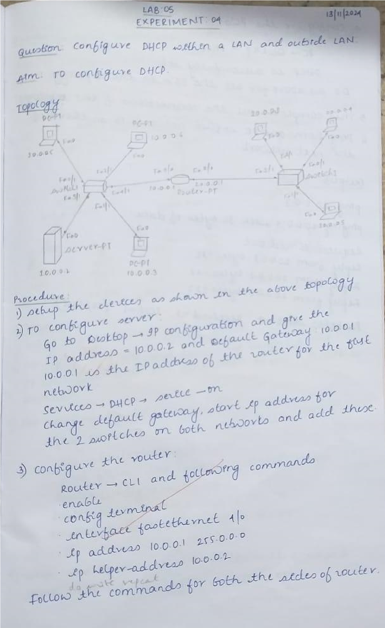

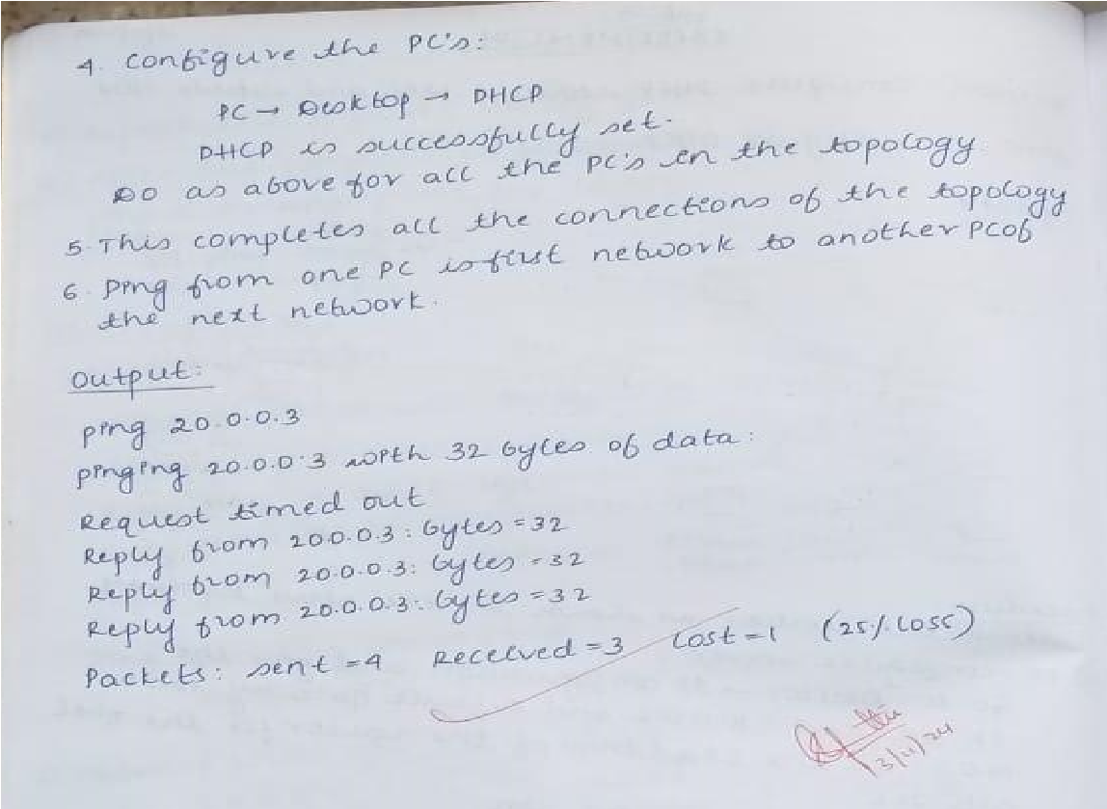

Screenshot of the topology:

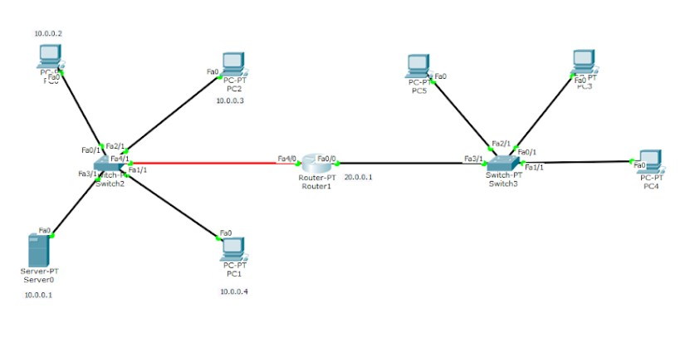

output:

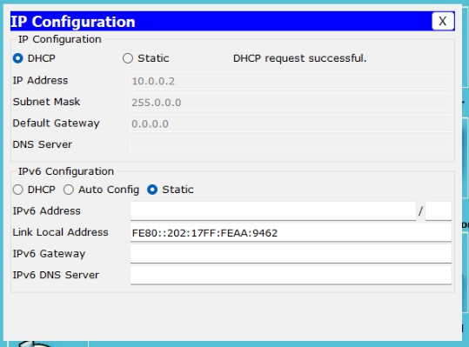

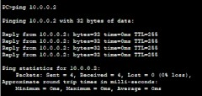

5:

Configure RIP routing Protocol in Routers.

Observation:

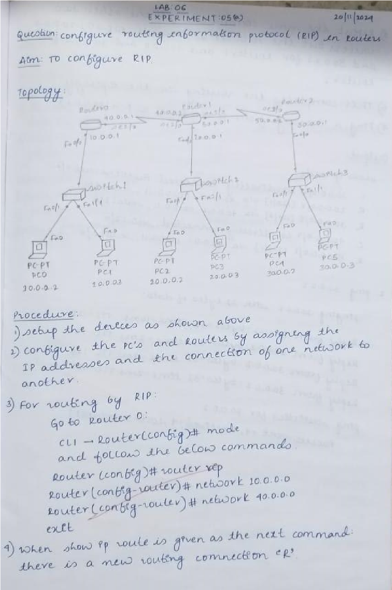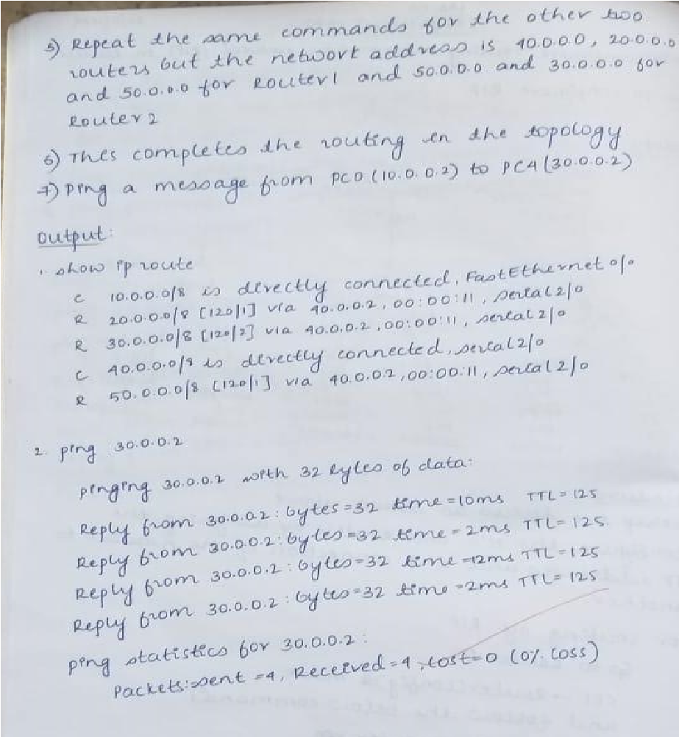

topology:

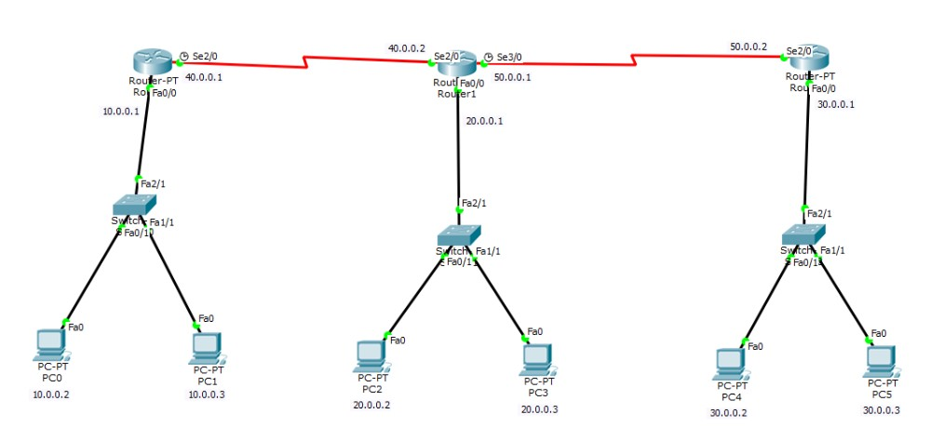

Screenshot of the output:

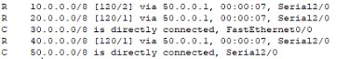

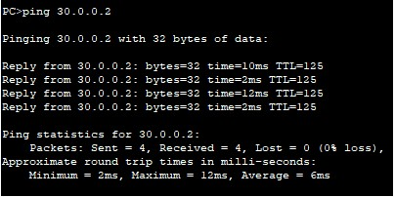

6:

Demonstrate the TTL/ Life of a Packet Observation writeup images:

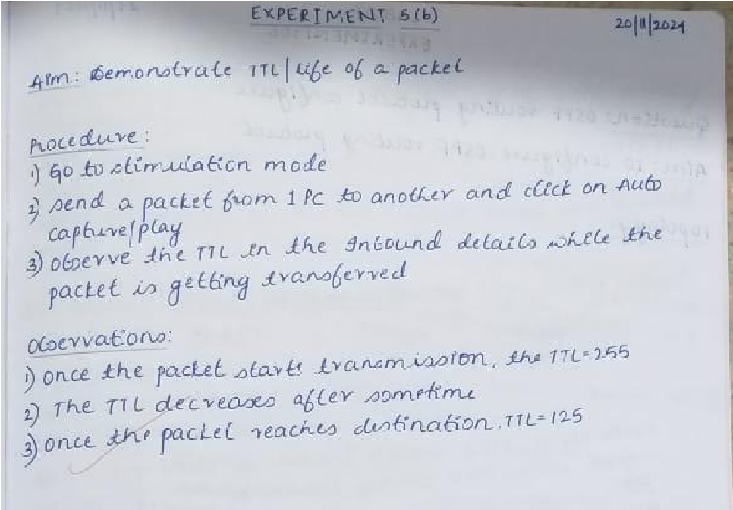

Screenshot of the topology:



output:

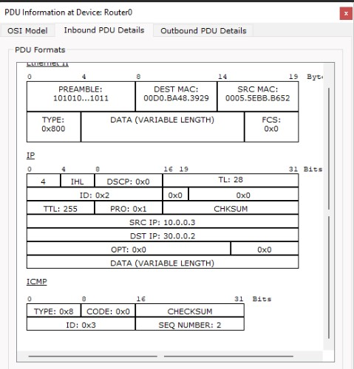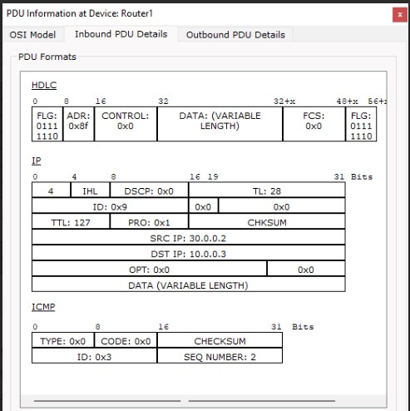

7:

Configure OSPF routing protocol Observation :

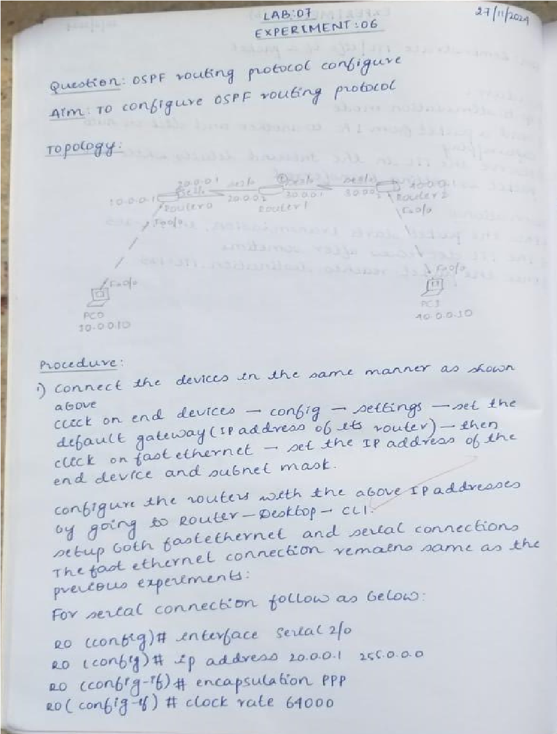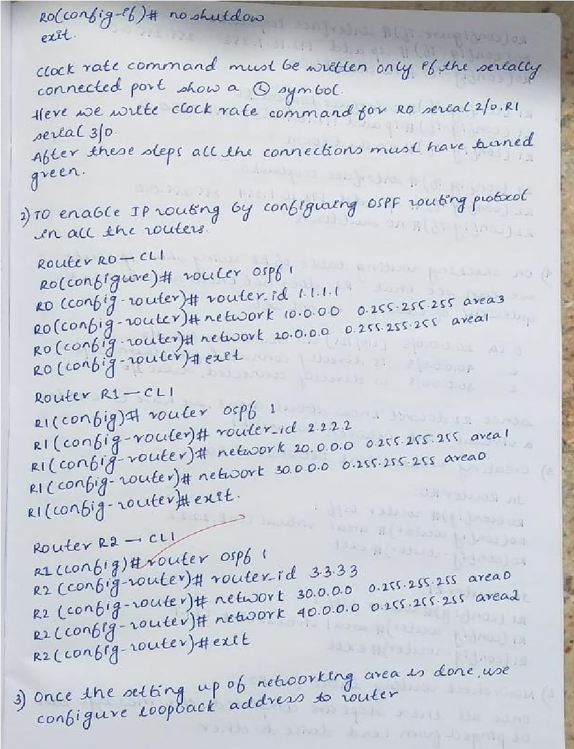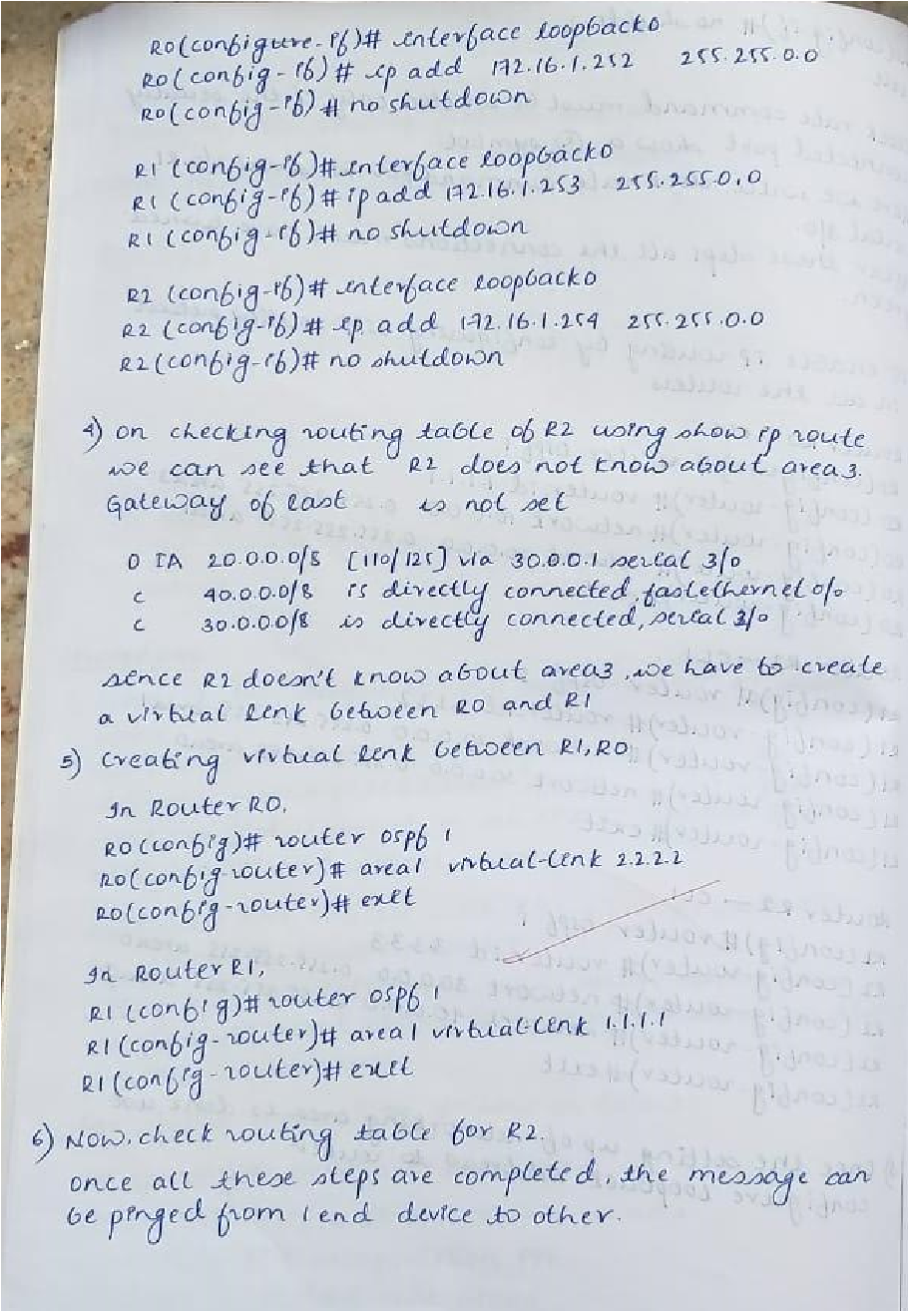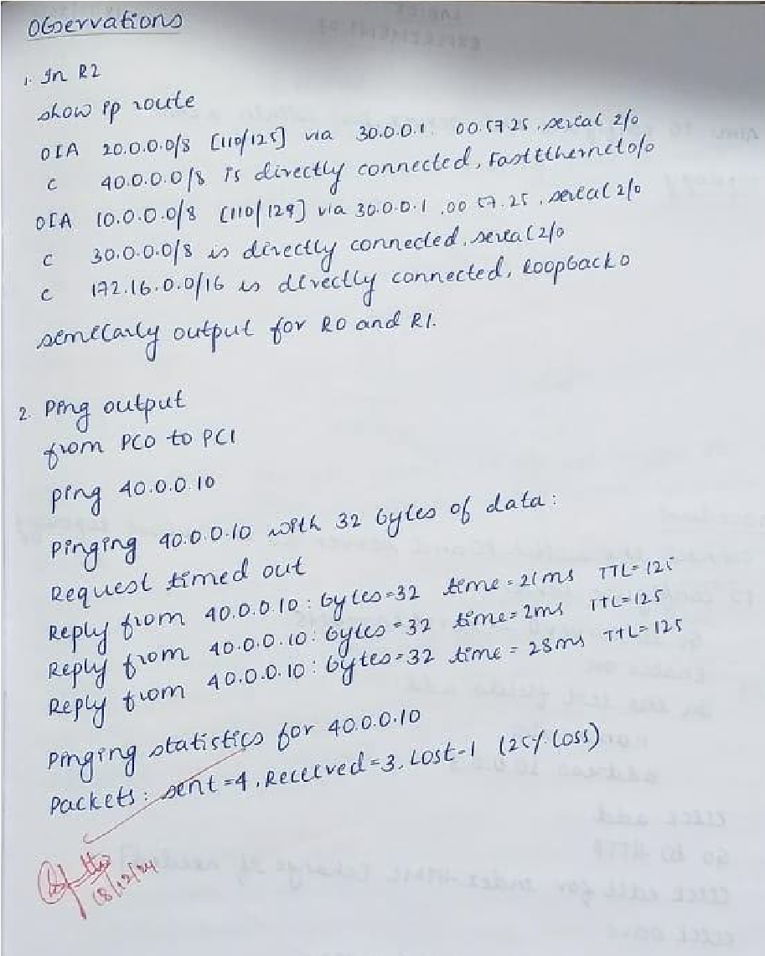

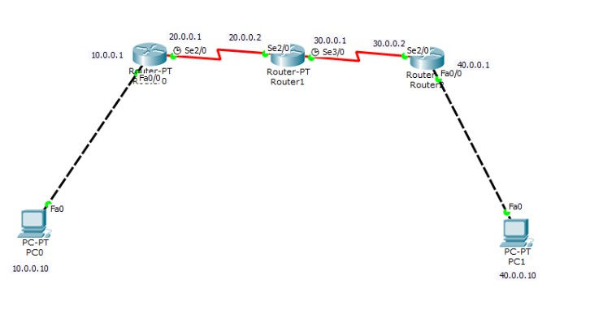

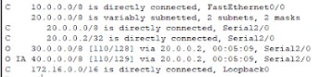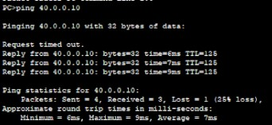Screenshot of the output:

8:

Configure Web Server, DNS within a LAN.

Observation:

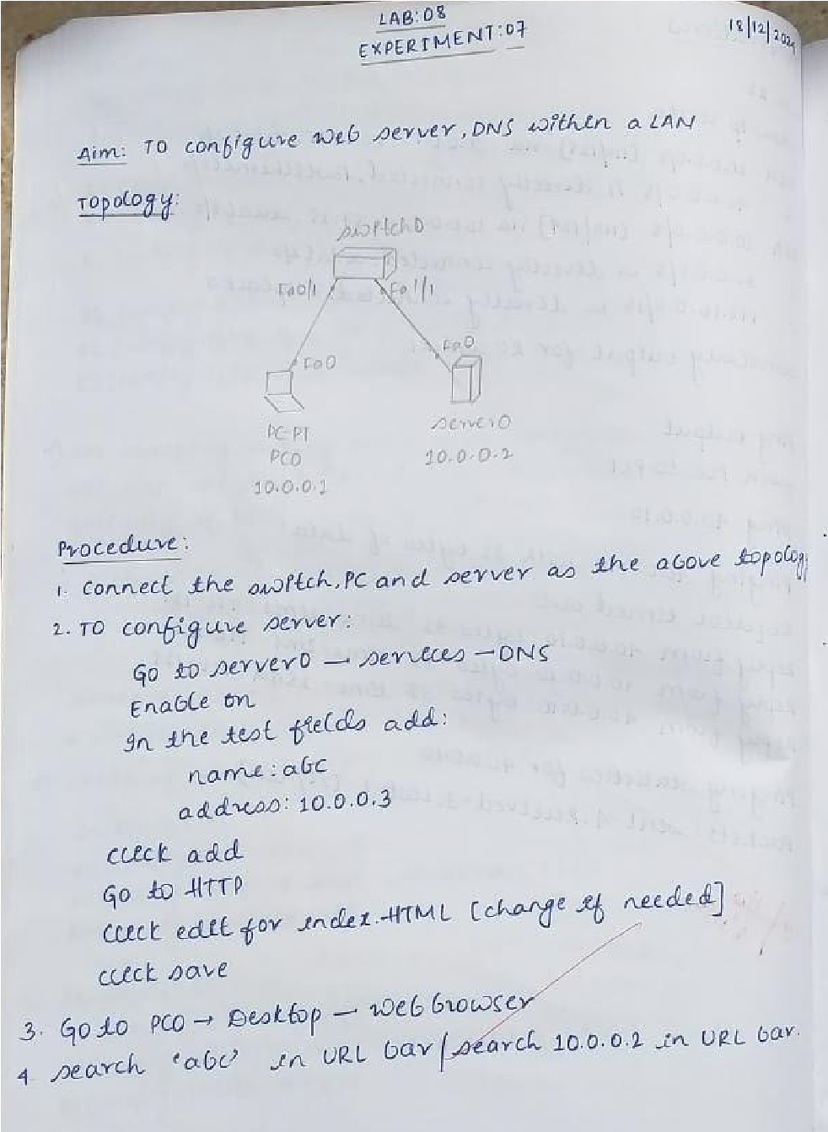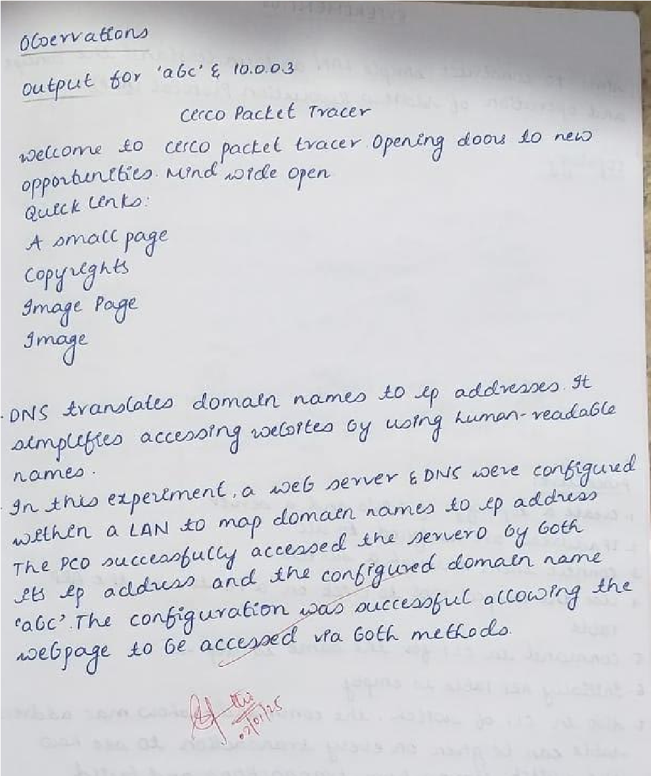

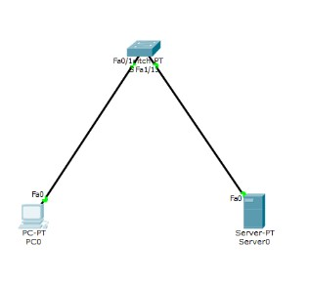

Screenshot of the output:

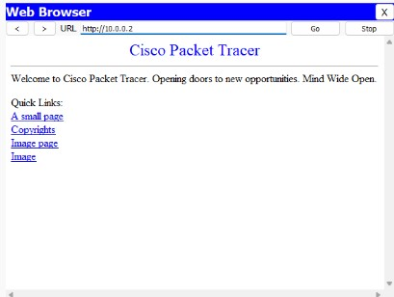

9:

construct simple LAN and understand the concept and operation of Address Resolution Protocol (ARP)

Observation:

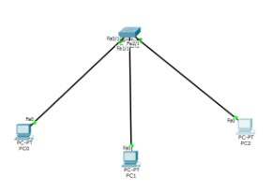

Screenshot of the output:

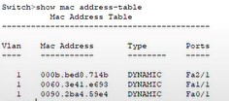

10:

understand the operation of TELNET by accessing the router in server room

from a PC in IT office

Observation:

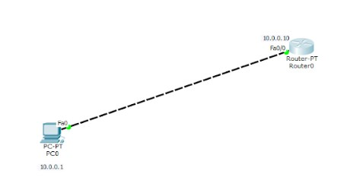

Screenshot of the output:

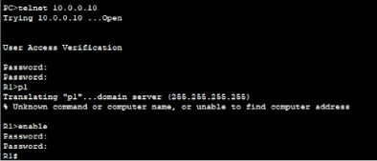

11:

construct a VLAN and make the PC’s communicate among a VLAN

Observation:

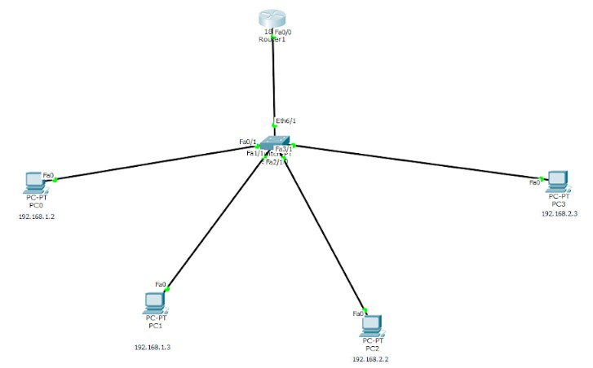

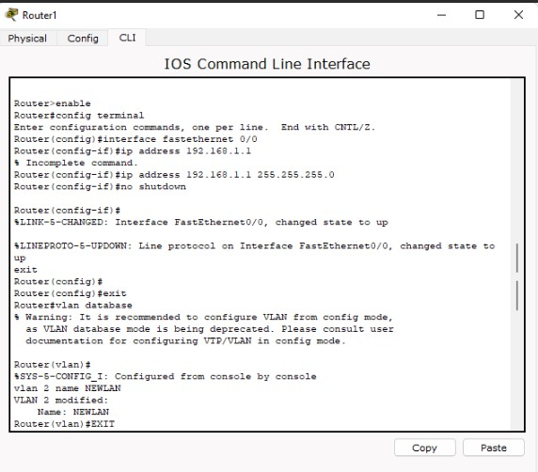Screenshot of the output:

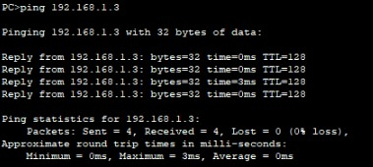

Question 12:

To construct a WLAN and make the nodes communicate wirelessly

Observation :

Screenshot of the topology:

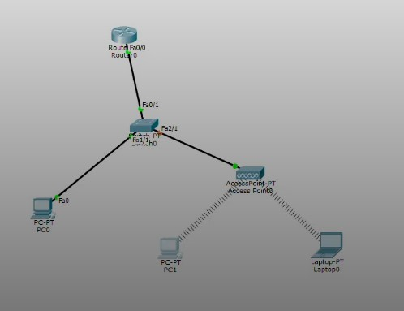

Screenshot of the output:

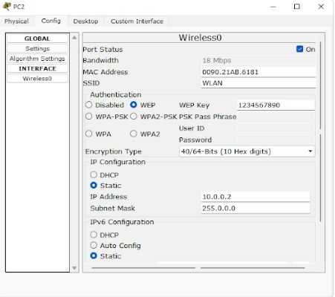

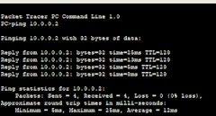

# CYCLE-2

Question 1:

Write a program for error detecting code using CRC-CCITT (16-bits).

Code:

def crc_ccitt_16_bitstream(bitstream: str, poly: int = 0x1021, init_crc: int = 0xFFFF) -> int:

crc = init_crc for bit in bitstream:

crc ^= int(bit) << 15 # Align the bit with CRC's uppermost bit for _ in range(8): # Process each bit if crc & 0x8000: # Check if the leftmost bit is set crc = (crc << 1) ^ poly

else:

crc <<= 1 crc &= 0xFFFF # Ensure CRC remains 16-bit

return crc

def append_crc_to_bitstream(bitstream: str) -> str: """

Append the calculated 16-bit CRC to the given bitstream.

""" crc = crc_ccitt_16_bitstream(bitstream) crc_bits = f"{crc:016b}" # Convert CRC to a 16-bit binary string return bitstream + crc_bits

def verify_crc_bitstream(bitstream_with_crc: str) -> bool: """

Verify the CRC of the given bitstream with CRC appended.

""" if len(bitstream_with_crc) < 16:

return False # Not enough bits to contain CRC data, received_crc = bitstream_with_crc[:-16], bitstream_with_crc[-16:] calculated_crc = crc_ccitt_16_bitstream(data) return calculated_crc == int(received_crc, 2)

# Main Program if __name__ == "__main__": # User input for original bitstream message_bits = input("Enter the original bitstream (e.g., 11010011101100): ").strip()

# Validate input if not all(bit in "01" for bit in message_bits):

print("Invalid input. Please enter a binary bitstream (e.g., 11010011101100).") else:

# Calculate and append CRC bitstream_with_crc = append_crc_to_bitstream(message_bits) print(f"Transmitted bitstream with CRC: {bitstream_with_crc}")

# User input for received bitstream user_bitstream = input("Enter the received bitstream for verification: ").strip()

# Validate received input if not all(bit in "01" for bit in user_bitstream):

print("Invalid input. Please enter a valid binary bitstream.") elif len(user_bitstream) < 16:

print("Invalid input. Received bitstream must include at least 16 bits for CRC.")

else:

# Verify CRC

is_valid = verify_crc_bitstream(user_bitstream) if is_valid:

print("No errors detected. CRC valid.")

else: print("Error detected! CRC invalid.")

Output:

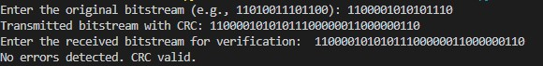

Question 2:

Write a program for congestion control using Leaky bucket algorithm.

Program:

Code:

storage=0 noofqueries=int(input("Enter no of queries:")) bucketsize=int(input("Enter bucket size:")) inputpktsize=int(input("Enter input packet size:")) outputpktsize=int(input("Enter output packet size:")) for i in range(0,noofqueries): sizeleft=bucketsize-storage if inputpktsize<=sizeleft: storage+=inputpktsize

else:

print("Packet loss=", inputpktsize) print(f"Bucket size={storage}out of bucket size={bucketsize}") storage-=outputpktsize

Output:

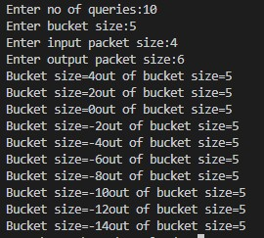

Question 3:

Using TCP/IP sockets, write a client-server program to make client sending the file name and the server to send back the contents of the requested file if present.

Program:

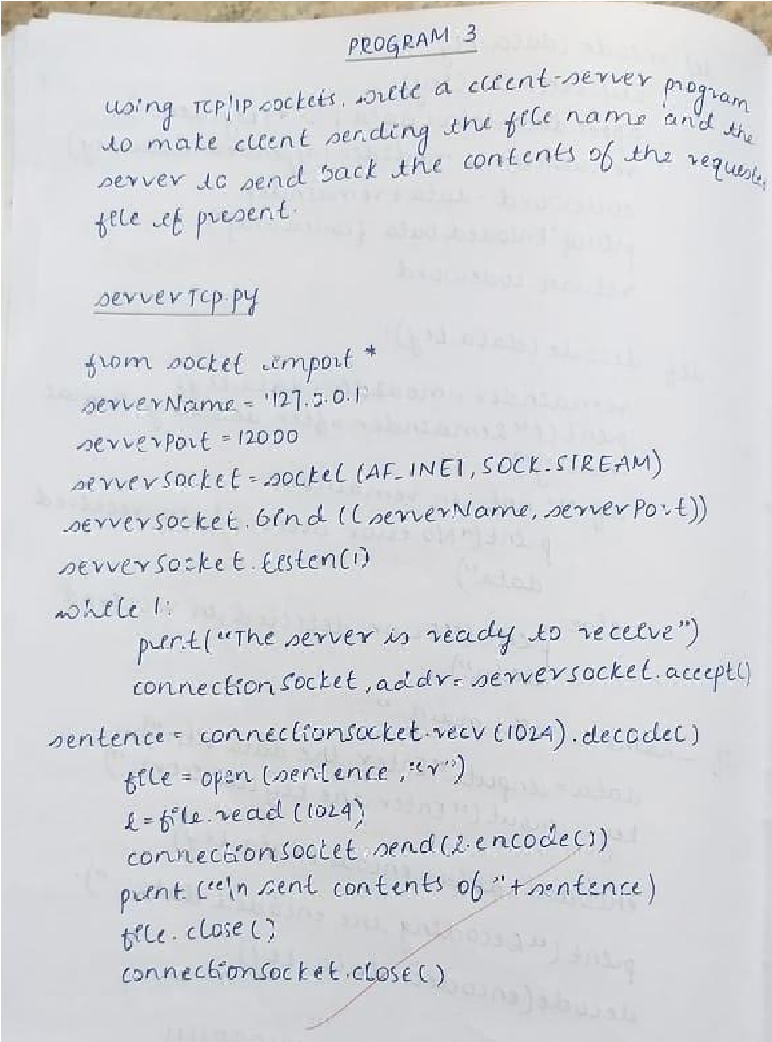

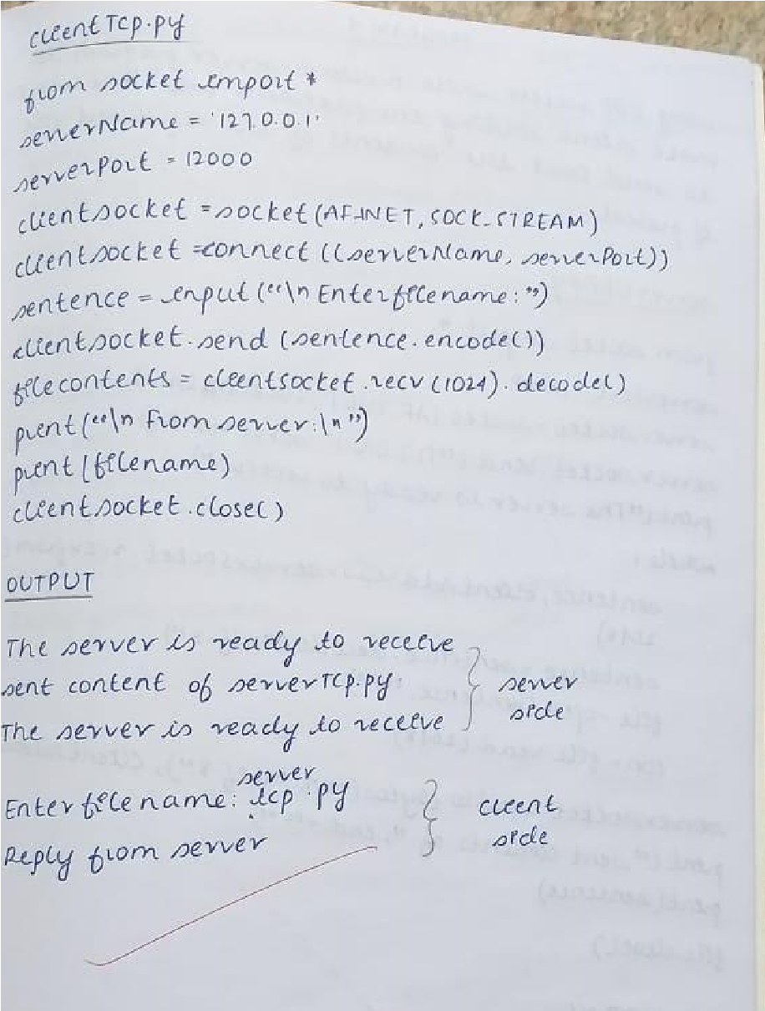

Code:

tcpserver.py: from socket import * serverName="127.0.0.1" serverPort = 14000 serverSocket = socket(AF_INET,SOCK_STREAM)

serverSocket.bind((serverName,serverPort)) serverSocket.listen(1) while 1:

print ("The server is ready to receive") connectionSocket, addr = serverSocket.accept() sentence = connectionSocket.recv(1024).decode() file=open(sentence,"r") l=file.read(1024) connectionSocket.send(l.encode()) print ('\nSent contents of ' + sentence)

file.close() connectionSocket.close() tcpclient.py: from socket import * serverName = '127.0.0.1' serverPort = 14000 clientSocket = socket(AF_INET, SOCK_STREAM)

clientSocket.connect((serverName,serverPort)) sentence = input("\nEnter file name: ") clientSocket.send(sentence.encode()) filecontents = clientSocket.recv(1024).decode() print ('\nFrom Server:\n') print(filecontents) clientSocket.close()

Output:

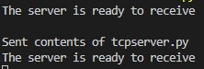

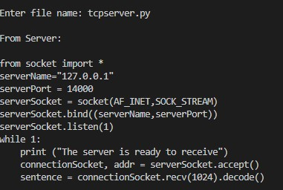

Question 4:

Using UDP sockets, write a client-server program to make client sending the file name and the server to send back the contents of the requested file if present.

Program:

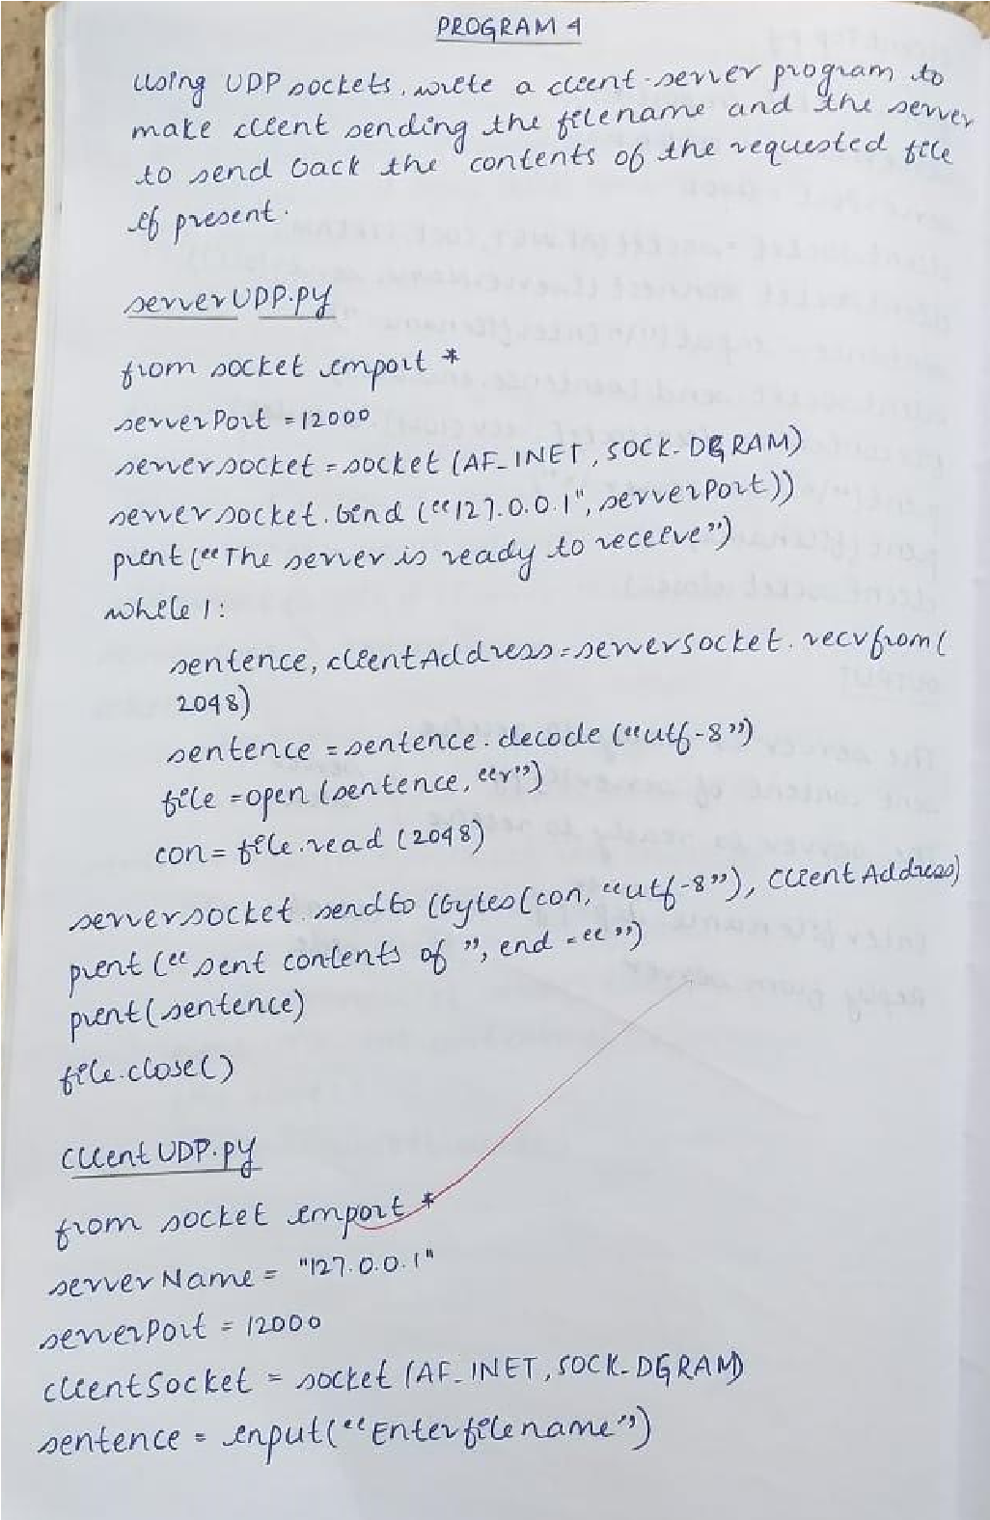

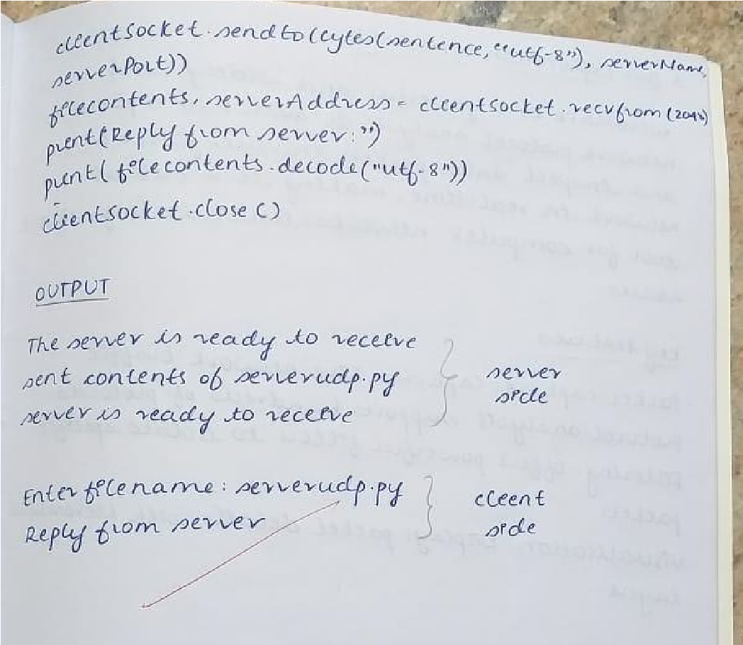

Code:

udpserver.py: from socket import * serverPort = 12000 serverSocket = socket(AF_INET, SOCK_DGRAM)

serverSocket.bind(("127.0.0.1", serverPort)) print ("The server is ready to receive") while 1:

sentence, clientAddress = serverSocket.recvfrom(2048) sentence = sentence.decode("utf-8") file=open(sentence,"r") con=file.read(2048) serverSocket.sendto(bytes(con,"utf-8"),clientAddress) print ('\nSent contents of ', end = ' ') print (sentence)

# for i in sentence:

# print (str(i), end = '')

file.close()

udpclient.py: from socket import * serverName = "127.0.0.1" serverPort = 12000 clientSocket = socket(AF_INET, SOCK_DGRAM) sentence = input("\nEnter file name: ") clientSocket.sendto(bytes(sentence,"utf-8"),(serverName, serverPort)) filecontents,serverAddress = clientSocket.recvfrom(2048)

print ('\nReply from Server:\n') print (filecontents.decode("utf-8")) # for i in filecontents:

# print(str(i), end = '') clientSocket.close() clientSocket.close()

Output:

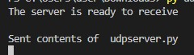

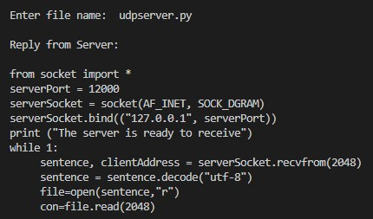

Question 5:

Tool Exploration -Wireshark

